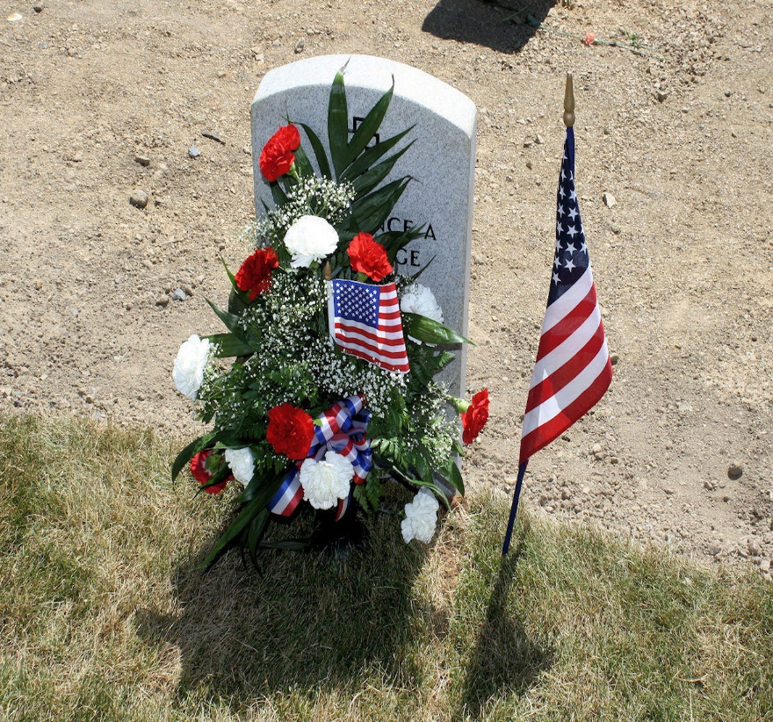
Welcome to the 2024 Providence Church Grief Share Information Page. Your participation in Grief Share—at whatever level you are comfortable—will help your understanding of the wide range of possible issues and emotions associated with the grieving process and will assist you in your journey toward healing.
Our in-person meetings will begin on March 9th at 1:00 at Providence Presbyterian Church on 77 Phillips Lane, Robinson Township, and will continue to meet each Saturday for Thirteen weeks. You may register on line OR register at the first meeting that you attend. With your registration, you have access to Grief Share’s on-line resources at www.griefshare.org (enter 15136 zip) where you can view additional information as well as the weekly videos. We look forward to your presence in our meetings, which will surely be a blessing to you and a comfort to the other participants, as well.
Sincerely,
Dale Baker, co-facilitator

